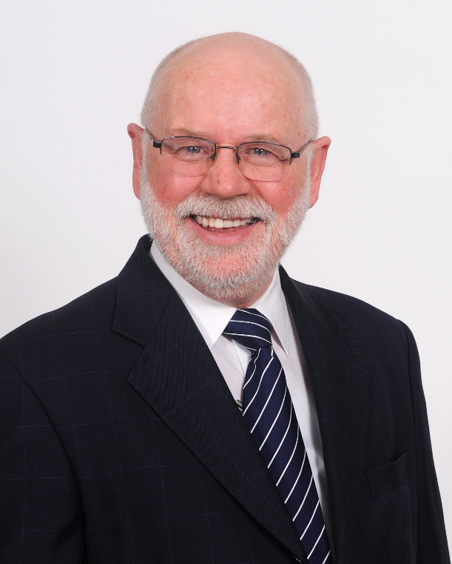
KEITH ROBERTS
Keith brings wide-ranging and relevant work and life experience to the Board. He has been a teacher, a soldier, held wide-ranging management roles including sales, marketing, production, public relations, corporate affairs, and industrial relations during 20 years in a large, listed company, then managed a health promotion charity for 14 years from 1992. A chartered secretary, he has consulted to not-for-profit organisations since 2006, mainly on restructuring, constitutions, improving board performance, and improving governance and administration.
A Member since the 1970s, Keith has confirmed family links to England, Scotland, Ireland and East Prussia, all pre-1850.

